Name and Surname:
402414088
Sbongumenzi Charlize Ndlovu
MOBILE APP DEVELOPMENT
27 September 2026
3
2
30 September 2026
BSc in IT
Student ITS No:

Date submitted:
Assignment due date:

Year of Study:

Qualification:
Semester:
QUESTION | EXAMINER MARKS | MODERATOR MARKS | REMARKS

ASSIGNMENT INSTRUCTIONS
richfield.ac.za
Please tick each box to confirm completion.
Use Times New Roman font, size 12, with 1.5 line spacing throughout the document. Apply Harvard Referencing Style for all citations and references.
For essay-style assignments, please include the following sections:
Table of Contents
Introduction
Main Body (with relevant subheadings)
Conclusion
References
Submit the assignment in PDF format on Moodle.
Use the specified cover page provided.
Include a signed declaration of originality.
DECLARATION OF ORIGINALITY:
I hereby declare that this assignment is my own work and has not been copied from any other source except where due acknowledgment is made. I affirm that all sources used have been properly cited and that this submission complies with the institution’s policies on academic integrity and plagiarism.
Student Signature: Date:
27 September 2026

Richfield Graduate Institute of Technology (Pty) Ltd is registered with the Department of Higher Education & Training as a Private Higher Education Institution under the Higher Education Act, 1997, Registration Certificate No. 2000/HE07/008.

Table of Contents
Introduction 2
System Design - Flow 3
System Design – Relationship 4
Screenshots of Output 5
Figure 1 5
Figure 2 6
Figure 3 6
Figure 4 7
Figure 5 7
Figure 6 8
Figure 7 9
Code Snippets 10
Normalization Code Snippet 10
Fun Fact Code Snippet 11
Strict Matching Code Snippet 12
Challenges and Solution 13
Challenge and Solution 1 13
Challenge and Solution 2 13
Challenge and Solution 3 13
Conclusion 14
References 15

Introduction
When building this app I had to take into account the amount of food that goes to waste because individuals either opt for takeaways or they do not know the various meals they can make with the ingredients they have in their pantry. This is a problem that is common amongst many households. For an adult coming back from work or a student coming back from school it is very common to open up the pantry and see the ingredients but not know what they can make with it and therefore leading to ingredients being left to spoil.

The smart pantry app that I built allows these everyday people to solve this problem and reduce food wastage and make use of the items they have. The app allows the users to be able to track the ingredients that they have and then suggest a recipe strictly based on the ingredients they have inputted into the app. I chose cuisines from different countries already preloaded into the database so that the user may have a larger variety of options and not having the same meal daily which can also lead to food wastage.

I followed the core rule of the brief which was that the app had to built around a strict matching system where a recipe is only suggested when every ingredient in that recipe is inserted in the pantry. When an ingredient is missing even if its just one the recipe will not display. The main focus was for users who want to cook at home but have no idea where to start with what they already have.

GitHub Repository Link:

System Design - Flow
The first part of the system design is the flow from the pantry to the suggested recipe. The main screen is the pantry list which then extends to the adding and editing and ingredient page, the suggested recipe page and also the settings page all which is accessible through the navigation buttons at the bottom of the screen. I handled the transition between each screen with Android Intent (Android Developers, n.d.) with this it is important to note that some screens like where the user adds an ingredient comes with a unique ID and so because of this the screen that is receiving this will automatically know exactly the next thing to load for the user.
This is the diagram for how the flow looks like:

System Design – Relationship
With the app it persists data using SQLite and I used or implemented SQLiteOpenHelper (Android Developers, n.d.)for this. Additionally there are three main tables that make up the entire schema which is the pantry table, the recipe table and the ingredients table. In addition to the relationship between the pantry items name to the recipe ingredients name there is also a relationship between the unit field in both tables.
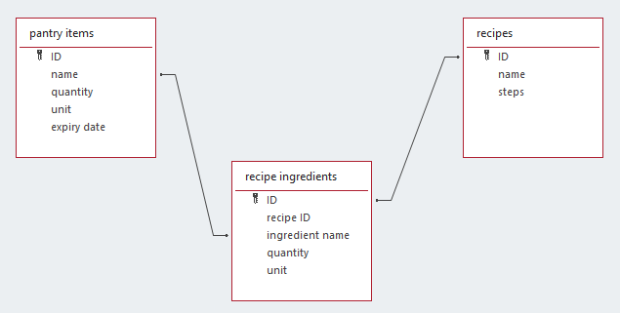

Screenshots of Output
These are the screenshots of the app tested on a physical device (Honor WDY-LX2) which I connected to android studio over WiFi debugging which displays the active run of the app against the like SQLite database.

Figure 1
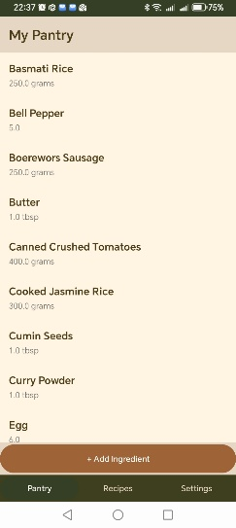
Figure 1: this is the home screen which shows some of the ingredients I added during the testing with the button to add an ingredient.

Figure 2
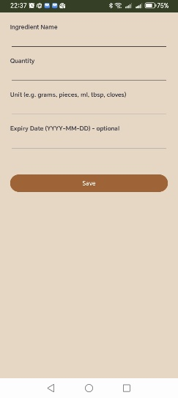
Figure 2: This is the add ingredient form when it is completely empty. Because there is no information the delete button is hidden and is only visible when there’s something to delete (as seen in figure 3).

Figure 3
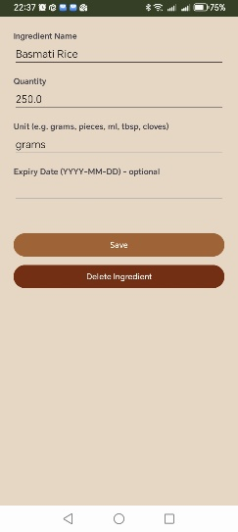
Figure 3: This is the same as figure 2 however this is now when a user is editing an ingredient where now the delete option is available.

Figure 4
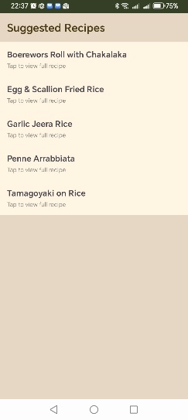
Figure 4: This is the suggested recipe screen listing the recipes that have a matching ingredient list to the one in the pantry (matching the strict rule).

Figure 5
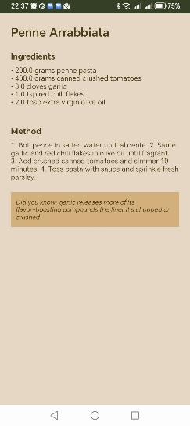
Figure 5: This is a recipe detail page for one of the recipes showing the ingredients and short preparation method along with a design I included myself where ingredients that appear often get their own fact as is above with Garlic.

Figure 6
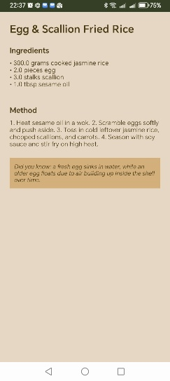
Figure 6: This is similar to figure 5 but with a different recipe and also with a different fun fact.

Figure 7
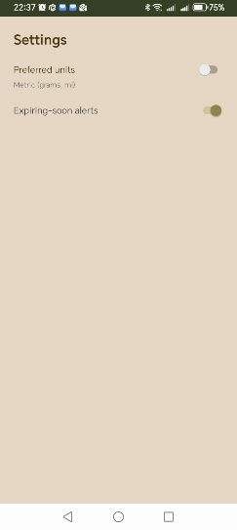
Figure 7: This is the last screen the setting screen which has working toggles for the preferred units and expiring soon alerts as mentioned in the brief.

Code Snippets
This is the first code snippet taken from the uploaded document on my github repository which is dedicated to handling how in some instances an ingredient may be written in the plural format. This code normalizes inputs like this so that they will be read or received the same and not disregard the ingredient due to the extra “es” or “s”.

Normalization Code Snippet
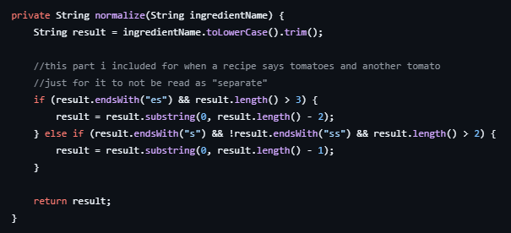

The second snippet is the fun fact addition which as seen in the screenshot displays that certain ingredients receive a fact because in the list of recipes I made that particular ingredients appears more than once. In addition to this it also includes logic that doesn’t display the fact when the ingredient is not in the recipe.

Fun Fact Code Snippet
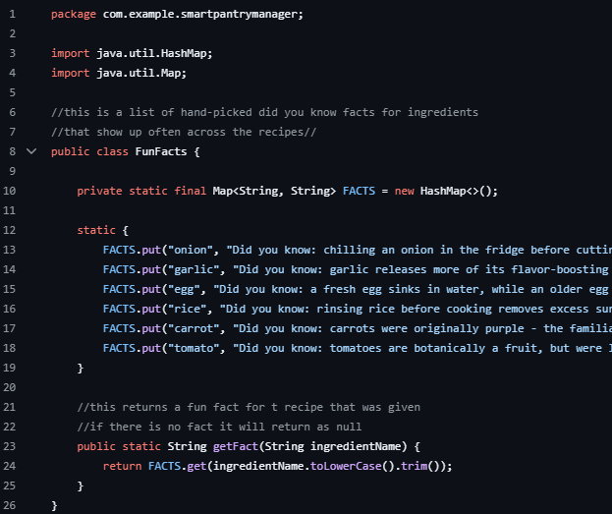

The last snippet is the one most important to the way my app operates especially in terms of the matching that was mentioned in the introduction and figure 4. The brief given instructed that a recipe can only be shown as suggested if every single ingredient that is needed is in the users pantry and so with that this is the code that I used to handle this.

Strict Matching Code Snippet
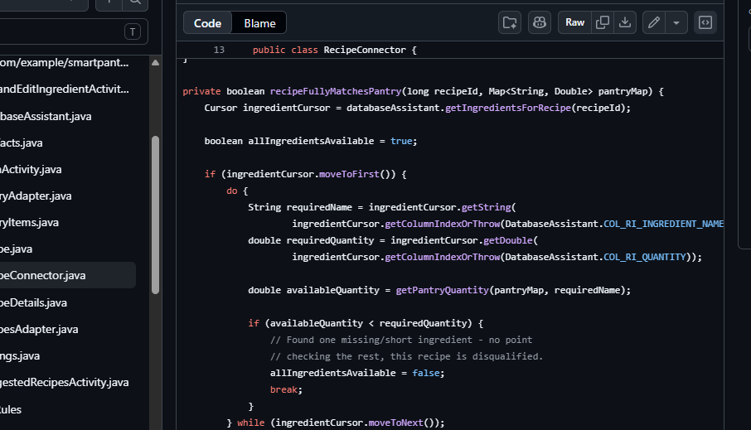

Challenges and Solution
While designing and building this app I ran into a lot of issues throughout the entire process such as some naming mismatching that led to runtime crashes, corrupted database assistants class and also a few typos that broke the custom drawable which led to the transition from the pantry list screen to the suggested recipe screen break, closing the app completely.

Challenge and Solution 1
When I was editing my DatabaseAssistant.java file to add the personalised recipe seed logic I mistakenly put the seed recipe method nested inside the on create method and because of this my app would not run at all and I had a lot of errors. To fix this mistake I had to rebuild the entire file from scratch to place the method in its correct place. When checking the problems panel the errors disappeared and my app was able to run .

Challenge and Solution 2
For the second challenge after I was naming and renaming files so that I would better understand what code was where when I ran into an issue this ended up leading to several errors throughout my entire project especially the files that relied on the content in these renamed files. One of the issues was that because of these named files the suggested recipe screen would crash immediately when I tried to open it and this is because although I edited the file names I had not gone back to update the other files which then led to a null pointer exception in my RecipesAdapter.java file (Android Developers, n.d.). To fix this I made use of android studios logcat tool to find where the error was with the exact line number and I also used the double shift method to search everywhere and then updated each file.

Challenge and Solution 3
The last challenge I has was when I was attempting to edit the background of the suggested recipes screen. I wanted to add an almost transparent background to that screen however this caused my app to break because the xml file was missing the source attribute. To fix this I found that my code include a spelling error however although after fixing the error the image still did not load and so I chose to abandon the idea and to rather keep my background simple and cohesive with the other screens.

Conclusion
In conclusion my app successfully meets the necessary requirements that was required such as the screens, rules, navigations etc and while seeing the final product of the app is rewarding to building this app required me to learn concepts such as the activity lifecycle (Android Developers, n.d.) and why certain methods are needed to keep screens in sync when switching from one screen to another. Additionally I had to how SharedPreferences (Android Developers, n.d.) can be used as another option a database especially one with setting that are simple. Debugging the app also required additional learning because in order to find error especially when using the logcat tool I had to read through each line carefully which was redundant as there were several bugs but entirely necessary.

If I was given more time there are quite a few specific extension I would want to add to the app. The first extension would be a seasonal suggestion where certain foods are suggest for a specific season. I would still follow the strict logic and have the recipe greyed out until the pantry contains the necessary ingredients. The second extension would be a fully operational light to dark toggle mode in the settings screen. Lastly another extension would’ve been to turn the deleted pantry items into a grocery list tab which would remind the user to restock on that item.

References
Android Developers, n.d. Activity. s.l.:s.n.
Android Developers, n.d. Create Dynamic Lists With RecyclerView. s.l.:s.n.
Android Developers, n.d. Intents and Intents Filters. s.l.:s.n.
Android Developers, n.d. Saving Data Using SQLite. s.l.:s.n.
Android Developers, n.d. SharedPreferences. s.l.:s.n.

